

***Giving a voice to those who cannot speak for 31 years!***

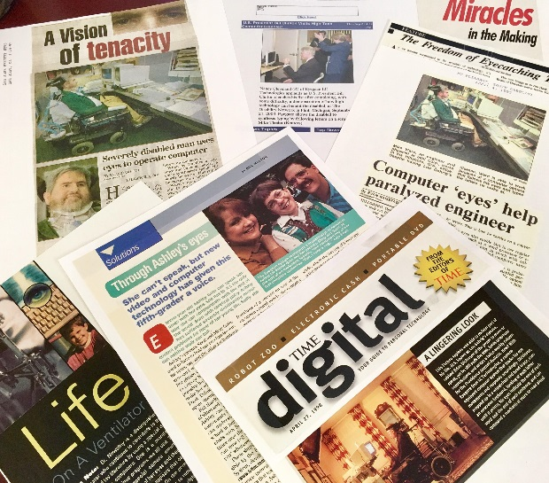

**President Clinton Tries The Eyegaze**

**Edge!**

The award-winning Eyegaze Edge® has been featured in hundreds of articles and we encourage you to read testimonials of Eyegaze Edge users.

Authors, Engineers, accountants, computer programmers, and teachers have used the Eyegaze Edge system to continue working, communicating and self-advocating. 13 books have been written using the Eyegaze Edge!

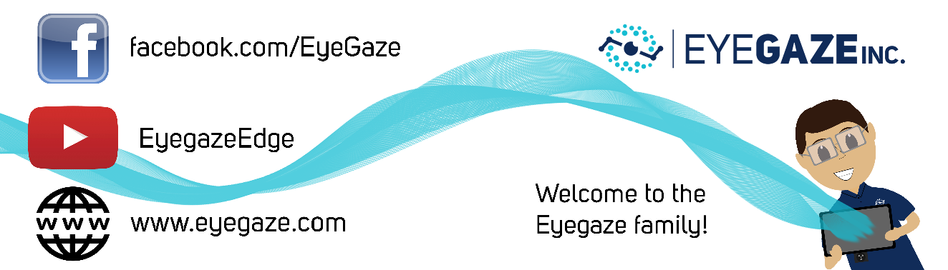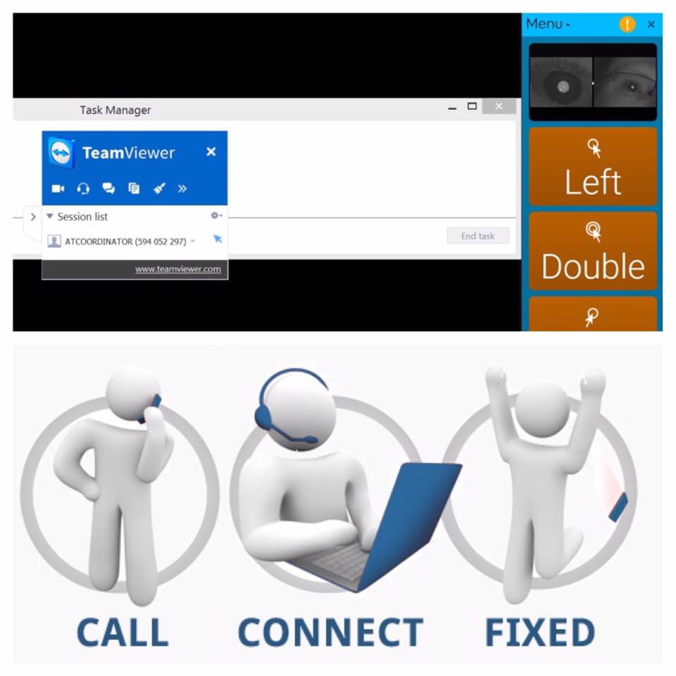

Eyegaze Inc. understands the needs of people with disabilities and complex medical histories. With over 30 years of research and development, we’ve fine-tuned the Eyegaze Edge as a medical device to meet their unique needs.

Your communication device is built by our talented technology team and is supported through face-to-face training, video tutorials, phone support and remote login access for the life of the device.

Our camera features low light levels, is simple to calibrate in any position and is the most accurate on the market.

Once purchased, you will join the Eyegaze Inc. Family of Eyegaze Edge users! Contact your local representative:

**Your Name**

**(123)456-7899**

email@domain.com