Positioning the
Eyegaze Edge®
With the Encore Camera

With a little practice, you will learn to position the Eyegaze Edge® correctly for successful calibration. There are a few reminders to have a successful experience:
- Watch the Eyegaze Edge® set-up video on the desktop of the device for review.
- Positioning the person and the device
- position the individual comfortably
- Position the screen between 18-27 inches away from their face.
- Ensure that the plane of the screen is parallel to the plane of the user’s face. If the person is reclined or laying down, position the screen to be parallel to the recline angle.
- Find the person’s eyes using the eye image on the screen. Position the person first, then the screen of the device, then the camera.
- Gently rotate the focus knob left or right until you obtain clear eye images on the screen.
- Use the on-screen eye image to guide you. This image tells us if the position is correct and allows us to see the user’s eye clearly during use.
A focused eye image should be crisp and clear like the image here. If not, make adjustments by rotating the camera lens to get a clear image
----------------------------------------------
The eyes are in the center of the right box
The center and left boxes show clear eyes without spots. The eye images should be focused, not blurry.
The glint spots of light are visible on the cornea

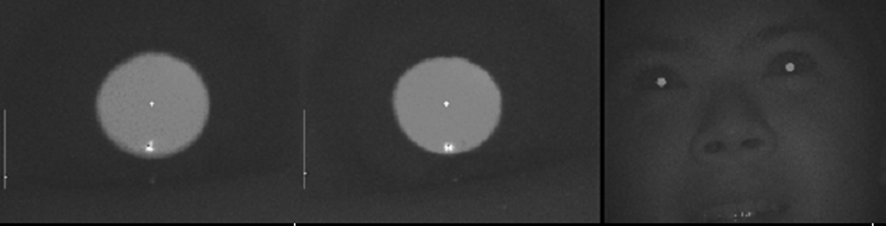

Troubleshooting
during Calibration
When you get stuck during the calibration process, it is a great time to exercise critical thinking skills about what might be wrong. Instead of getting frustrated, ask yourself, “what else can I change to possibly get a different outcome?” Start by trying these tips to get an accurate calibration (less than 0.5 inches).

- Change the position of the Eyegaze Edge® slightly: move it up or down, backward or forward, left or right, or change the angle slightly. Sometimes this slight change in position will help.
- Observe the environmental light and change if you see a glare on the user’s glasses. Make sure the glasses are clean.
- Evaluate whether or not their eyes are dry: is it later in the day? Is there a glint spot on the cornea? Is the eye image on the screen inconsistent? Use eye drops if needed.
- Skip a calibration point if needed (hit Fn + F2 on your keyboard) to avoid frustration.
- Pull up the calibration shortcut menu (Ctrl + C) and change from 9 calibration points to 5 points, or change from a small calibration point to a larger one. Remember that we start with 9 small yellow balls, and then move to fewer and bigger targets only as needed.
- If the person has difficulty focusing on the calibration point, give a verbal cue and point to it with your finger.
- If the person only has 1 working or 1 dominant eye, change the settings to track only 1 eye instead of 2.
- If all else fails, connect the device to the internet and phone LC’s technical team for remote support (1-800-EYEGAZE). LC’s technical team will see the eye image and coach you through calibration.
- After calibration, a flash of calibration numbers will appear on the screen. To pause this display, simply press the space bar on the keyboard.
- Want to start calibration over again? Hit Fn + F1 on the keyboard.
- Want to exit the calibration screen? Hit ESC on the keyboard.

