The Eyegaze Edge must be disinfected prior to loaning it to a user. The following procedure will clean the system without harming it. Please note: this procedure is intended only for cleaning the Eyegaze Edge. We cannot guarantee it will be safe to use on other systems.
Step 1:  Disconnect the camera from the Eyegaze tablet.  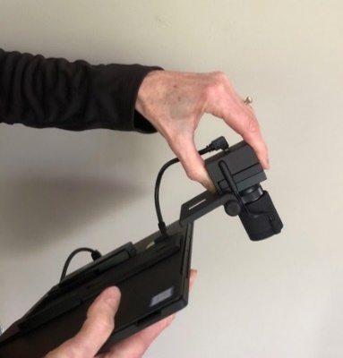 | Step 2:  Wipe the tablet surface with70% or 90% isopropyl alcohol. Wipe the tablet’s front, back, and edges, paying close attention to ensuring no alcohol gets into the ports. Putting alcohol inside of a port can cause serious damage to the computer.  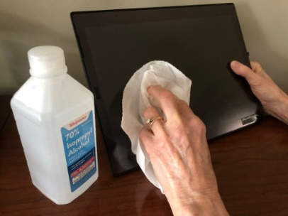
Step 3:  Wipe all the camera surfaces with isopropyl alcohol, being sure to avoid getting alcohol into the port and camera aperture.  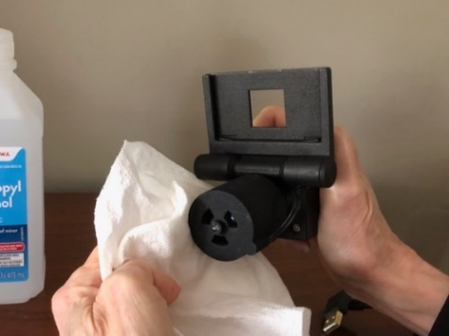 | Step 4:  Wipe all cables and connectors with isopropyl alcohol.  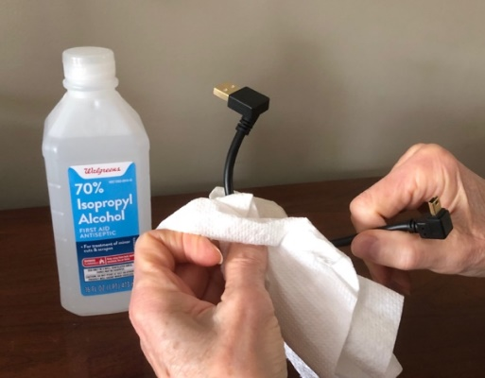
Step 5:  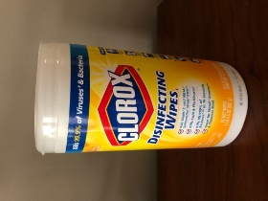  Clean the mount. You may use either isopropyl alcohol or any antibacterial wipe, being sure to wipe all surfaces. | Step 6:  Be sure all components are completely dry before packing.

