The Eyegaze Edge®: How does it work? What do you need to know?

Eye tracking overview
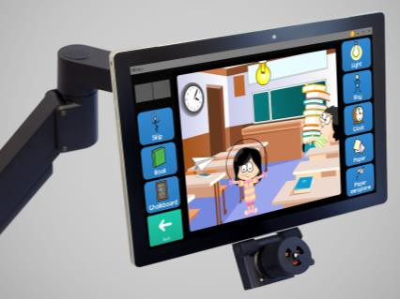
The Eyegaze Edge is an eye-controlled communication and control system. The Edge uses the pupil- center/corneal-reflection method to determine where the user is looking on the screen. An infrared-sensitive video camera, mounted beneath the system's screen, takes 60 pictures per second of
the user's eye. A low-power infrared light emitting diode (LED), mounted in the center of the camera's lens, illuminates the eye. The LED reflects a small bit of light off the surface of the eye's cornea. The light also shines through the pupil and reflects off of the retina, the back surface of the eye, and causes the pupil to appear white. The bright-pupil effect enhances the camera's image of the pupil so the system's image processing functions can accurately locate the center of the pupil.

The Edge calculates the person's gaze point, i.e., the coordinates of where they are looking on the screen, based on the relative positions of the pupil
Eyegaze Edge® Tablet

center and corneal reflection (glint spot) within the video image of the eye. Typically the Eyegaze Edge predicts the gaze point with an average accuracy of a quarter inch or better. The glint spot in Figure 2 is at 6 o’clock in
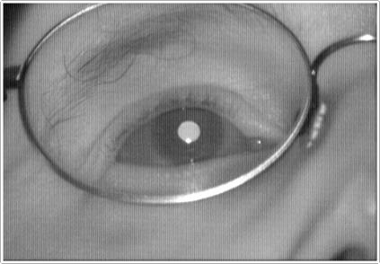
relation to the pupil center. As the user gazes around the screen the location of the glint spot changes. The vector from the glint spot to the pupil center indicates which direction the eye is pointing in relation to the camera. This user is looking straight up from the camera. If he looks to the upper left the glint spot appears below and to the right of the pupil. If he looks up and to the right, the glint spot appears below the pupil and to the left.
Some eye-operated systems use a dark pupil and one or several reflections on the cornea to do the gaze point prediction; some systems use both bright- pupil and dark-pupil eye tracking. All eye-operated systems locate the pupil

Figure 2: Bright-pupil eye image
center in order to predict a user’s gaze point, and all require a calibration of the user’s eye.

A user calibrates the Eyegaze Edge by looking at a small circle displayed on the screen, and following it as it moves around the screen. The calibration procedure is automated and typically takes about 15 seconds. Once calibrated, the user does not need to recalibrate if he moves away from the Eyegaze Edge and returns later.

Physiologic Considerations

Normal eye movement
The human eye moves in a series of fixations and saccades. During a fixation, which typically lasts between 1/5th and 1/3rd second, the eye remains still, focused on a single point. Saccades are used to bring the eye rapidly from one fixation to another. Saccades typically move at speeds between 200 and 600 degrees/sec. Moving the eyes from one edge of a 15-inch screen to the opposite edge takes about 1/16th of a second. Though people are not conscious of it, they do not “see” during saccades: “saccadic suppression” prevents the brain from processing the blurry image while the eye is in motion. Injuries and illnesses may impact the ability of the eyes to move normally, or on their ability to fixate.

Fatigue
The muscles that move the eyes do not have the ability to fatigue. The ocular muscles that rotate the eyes are both very strong (to achieve rapid saccades) and very precise (to get stable images during fixations.) The eyes move constantly, 24 hours a day, even while we are asleep. “Eye fatigue” is, in fact, the result of tired eyelid muscles, not tired ocular muscles. We experience what we perceive as eye fatigue when it is difficult to keep our eyes

open. Positioning the Eyegaze screen slightly below eye level can minimize eyelid fatigue, since looking up at a screen forces a user to hold their eyelids wide open in order to see the screen. An eye-operated system should never require its user to look up.
Eyegaze users report less fatigue with short gaze durations (dwell times) for selection: typically ranging from 1/5 to 2/3 second. Holding the eyes still, focusing on a small target, may cause fatigue because it is contrary to normal saccadic movement. Accommodating short fixation times requires high gaze point prediction accuracy in the eye tracking instrument. The Eyegaze Edge achieves that accuracy.
Communication programs with great graphics and bright colors are typically not functional for Eyegaze use. Screens that work well with switches, pointers, and touch-screens aren’t usually optimal when the input method is the eyes. Bright, colorful screens with a large amount of content contribute to user fatigue: even many computer users in the general public report discomfort looking at bright screens for prolonged periods, and they’re not controlling them with their eyes.
Because the Eyegaze system is, in effect, its user’s voice, they should be able to generate speech with it all day. Eyegaze users may choose to run a communication program designed for other input methods. We recommend modifying the screen colors to darker shades, and eliminating unnecessary content to make those programs more comfortable for Eyegaze use.

Anatomical variations
Potential Eyegaze users should be able to look up, down, left and right. They should be able to fix their gaze on all areas of a 12-15 inch screen that is about 20 to 30 inches away from their face. Ideally, they should be able to focus on one spot for at least 1/2 second, although the Edge can predict a user’s gaze point with shorter fixations. Many common problems that may affect Eyegaze use are automatically addressed by the Eyegaze Edge’s image processing software. Those include:
Ptosis of the eyelids: Ptosis (drooping) of the eyelids is a fairly common occurrence in the general population, and quite common in people with ALS, brain injuries, and brainstem strokes. Because most eye-operated systems find the pupil center by drawing cross hairs over the pupil, their accuracy degrades considerably when the pupil is not round. A mis-identified pupil center may shift the gaze point prediction by several inches, making accurate eye selection difficult or impossible on part of the screen. Eyegaze Inc. has a unique method for determining the true pupil center in those circumstances. Droopy Eyelid Compensation software in the Edge automatically detects a partially blocked pupil, locates the true pupil center and accurately predicts the user’s gaze point. It is unusual for the user of any Eyegaze system to be unable to accurately target part of the screen. If the user experiences poor targeting, look for pupil occlusion.
Large and small pupils: Large pupils are quite common in children, and even more common in children who are taking baclofen to relax their muscles. Baclofen commonly causes midriasis, an abnormally dilated pupil. The effect on eye tracking is the same as that caused by ptosis of the eyelid: the pupil is partially blocked by the lid. Droopy Eyelid Compensation effectively eliminates that problem.
Irregularly shaped pupils, asymmetric pupils: The Edge’s unique Asymmetric Pupil Compensation setting compensates for a pupil that doesn’t dilate and constrict evenly. This phenomenon occurs most frequently in ALS, probably the result of motor neuron damage to one of the pupillary muscles. Without this modification the user’s gaze point will not be accurately predicted, resulting in difficulty accessing keys on part of the screen.
Cataracts: On the eye image display, a cataract appears as a darkened spot on an otherwise bright pupil. Depending on its size and location a cataract may affect the system’s ability to calculate the gaze point accurately. If the cataract is blocking a pupil edge, Droopy Eyelid Compensation may work. If the user chooses to have cataract surgery the Edge will track their gaze point accurately post-surgery.
- Alternating strabismus (eyes cannot be directed to the same object, either one deviates):
The Eyegaze Edge is constantly tracking the same single eye. If, for example, a user with alternating strabismus is operating the Eyegaze Edge with the right eye, and that eye begins to deviate, the left eye will take over and focus on the screen. The Eyegaze camera, however, will continue to take pictures of the right eye, and the system will not be able to determine where the user's left eye is focused. When the left eye deviates and the right eye is again fixed on

the screen the Eyegaze Edge will resume predicting the gaze point. Putting a partial eye patch over the nasal side of the eye not being observed by the camera often solves this tracking problem. Since only the unpatched eye can see the screen, it will continuously focus on the screen. By applying only a nasal-side patch to the other eye there will be no loss of peripheral vision on that side.

Medication Effects on the Eye
Midriasis: See discussion of large pupils above.
Nystagmus: The constant, involuntary eyeball movement which is nystagmus is generally not noticed by the person experiencing it. The brain filters out the bounce, and their view of the world appears normal. Nystagmus is a fairly common side effect of anti-seizure medications. Because the user’s gaze does not remain fixed on a given location for more than a fraction of a second, most eye trackers cannot calibrate that eye. The Edge has a modified calibration that can often capture the eye fixation between bounces, enabling the user to calibrate. Because of the bounce, the gaze duration must typically be set to a short (fast) dwell time during actual use of the system.
Blurred vision, diplopia (double vision): These common medication side effects can make Eyegaze use more difficult for the user. A user with diplopia may benefit from a nasal-side partial eye patch so he only views the screen with one eye.

Positioning

Screen Position
In a perfect world, every Eyegaze user would be sitting in a great wheelchair that supported their trunk in an erect position, and their face would be parallel to the screen. In the real world, a user may, in fact, be leaning to one side or lying on their side. Our brains do a beautiful job of sorting out the visual world when our heads are tipped to the side. Angling the screen to match the angle of a user’s head is not a good solution for the user: their brain wants the screen to be erect, matching the rest of their visual world. The Eyegaze Edge is the only eye-operated system that can accurately calibrate a user with the head at any angle. There is no need to accommodate the system by tilting the screen: the Edge will accommodate the user and predict their gaze point accurately no matter what position they are in.

Screen Location
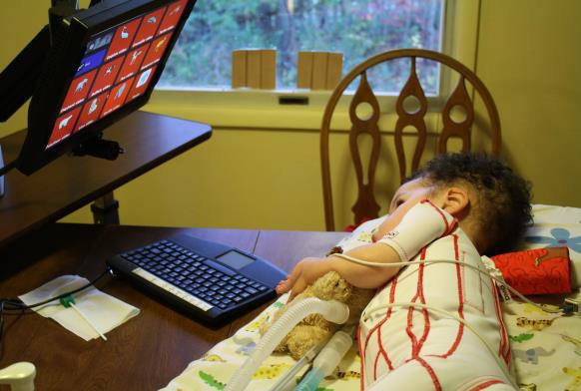
A user should be able to determine precisely where they’d like their Eyegaze screen. The Eyegaze Edge has an external camera that can be adjusted to the comfort of the user. While most users prefer the top of the screen at eye level and in front of them, the Edge can be positioned considerably below eye-level or off to the side so it doesn’t block the user’s field of view. As long as the Edge system’s camera is able to see the user’s pupil, no matter what their position or the position of the screen, the Edge will work. It can be focused so the user is as little as 18 inches from the screen or as far away as 30 inches, depending on the
user’s preference. Side-lying 18 month old user

Considerations Based on Medical Diagnosis

Amyotrophic Lateral Sclerosis (ALS):
People with ALS are generally very successful operating the Eyegaze Edge. Consideration must be made for potential eye challenges as a result of the progression of the disease. Users with ALS may in time experience droopy eyelids, dry eyes, or inhibited range of eye movement. Adjustments to both the Eyegaze software and hardware may often accommodate those issues. Droopy Eyelid Compensation in the Eyegaze Edge will automatically accommodate users with ptosis of the eyelids.
Over time, people with ALS may have a decreased blink rate. The eyes surfaces (corneas) are normally moistened by tears, which are spread around by blinking. As the blink reflex decreases, the corneas dry out, and don't reflect infrared light very well. Eye trackers need to see a corneal reflection in order to function. Using over-the-counter artificial tears eye drops will typically provide adequate moisture. The ECS Settings program

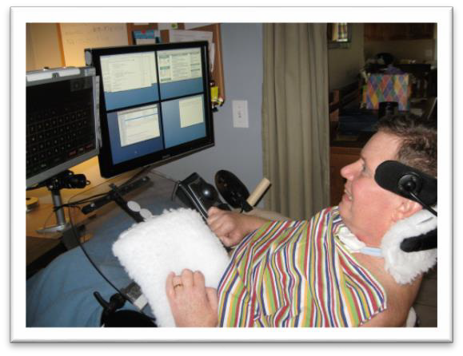
User programming a Mac with Eyegaze Edge

includes a diagnostic tool to help determine dry eyes. The Edge calculates the user’s distance from the screen extremely precisely. When Focus Range Compensation is active and the user has dry eyes, congealed tears on the surface of the cornea will affect the range prediction, causing the eye image to display changes in color to alert the user that their eyes may be dry. The eye image will alternate between red and green as it tries to find the correct range. If turning off the Focus Range Compensation results in a return to normal Eyegaze function it has diagnosed the problem.
Limited eye movement in some people with very advanced ALS makes it difficult or impossible for them to perform the more complex Eyegaze functions, such as typing, on traditional Direct-select Eyegaze keyboards. Two solutions are included in every Eyegaze Edge: a large-key two-stroke keyboard and a scanning keyboard with an eye motion switch. Additionally, the optional Grid 3 Eyeworld program makes it possible to create custom screens that can accommodate limited eye movement.

Brain Injuries:
Traumatic and anoxic brain injuries can result in a variety of problems that may affect Eyegaze operation. Cognition, memory, concentration, or even the ability to read may be affected by the injury. Vision problems are also common. In general, if the person demonstrates a consistent way to communicate yes and no, it can be assumed there is a level of cognition that is sufficient for some Eyegaze use. Often memory and attention problems become apparent during the process of evaluating the user with Eyegaze.
Vision problems such as diplopia, blurred vision, alternating strabismus and homonymous hemianopsia (vision field-cut) may also impede Eyegaze use. Cranial nerve damage may limit the user's ability to control their eye movements. For alternating strabismus or double vision, applying a nasal-side patch to the eye that is not being tracked may solve the problem. This intervention causes one eye to consistently look at the screen, providing maximum gaze point accuracy, without impeding peripheral vision on the partially patched eye. The user retains a full field-of-view. Additionally the Edge Settings program offers a variety of adjustments that enable a user to activate an Eyegaze key quickly, but provide a short recovery period to give them extra time to move their eyes off a target and onto the next. If the user has a vision field-cut, customized screens in the Grid 3 may be created to avoid the area of the screen the user can’t see.

Cerebral Palsy:
Many children and adults with cerebral palsy are currently using Eyegaze systems to participate in school, from kindergarten through college, and in the workplace. People with CP who have uncontrollable head motion may not find Eyegaze operation always acceptable, since the Edge camera has a limited field-of-view, but often that can be corrected with good wheelchair positioning supports. Since the Edge is able to accurately predict the

user’s gaze point at indirect angles to a user’s face, a user can operate it even if he is leaning to the side, without changing the angle of the screen. For many users with CP this feature is extremely valuable, often eliminating the need to constantly re-position the screen.
Because controlling the eyes does not elicit a movement response in the body, many people with CP are proficient Eyegaze users. The eyes are a part of the brain, and controlling them does not cause movement in other parts of the body once the user becomes relaxed. The Eyegaze Edge re-acquires the user's eye in 1/30th of a second if he moves out of the camera’s field of view and returns. This re-acquisition of the eye is so fast that the user does not perceive it. A variety of eye movement problems are also often associated with CP, most commonly alternating strabismus. It may be necessary to partially patch one eye for accurate use.

Multiple Sclerosis:
It may be necessary to increase the font size of the Eyegaze screens (done in the Settings program) if the multiple sclerosis has affected the user’s vision. In the past, prior to the advent of medications to treat MS, steroids were used to treat exacerbations of the disease. Cataracts are a common side effect of frequent steroid use and can interfere with eye tracking. If the cataract is removed the Edge will typically track the user's eye with out difficulty.

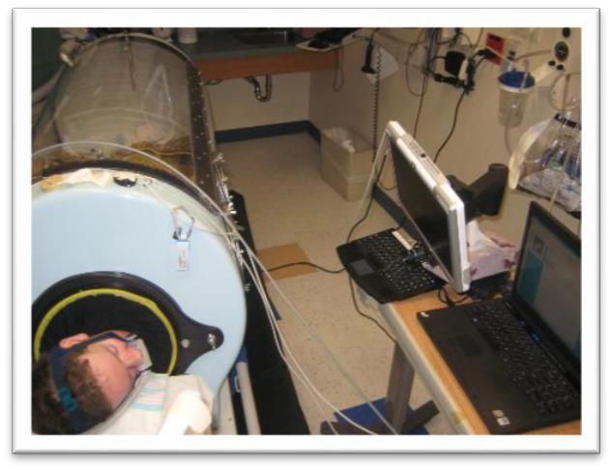
Muscular Dystrophy, Spinal Muscular Atrophy, Werdnig-Hoffman Syndrome:
Eyegaze user with SMA in the ICU
Children and adults with MD, SMA, and Werdnig-Hoffman are typically good users who benefit from the ease of positioning of the Eyegaze Edge in regard to their own unique positioning needs. Children with SMA as young as 15 months are able to use the Edge effectively.

Rett Syndrome:
After evaluating several dozen girls with Rett syndrome we have not determined any predictors for successful Eyegaze use. Many of the girls were too easily distracted to use Eyegaze in any meaningful way, although they were able to calibrate without difficulty. More research should be geared toward using eye tracking analysis software to determine the efficacy of Eyegaze use with Rett Syndrome for communication.

Spinal Cord Injuries:
Quadriplegia resulting from spinal cord injury presents no limitations for Eyegaze operation. The system is often an excellent tool for people who are ventilator-dependent and quadriplegic, especially if they are non-verbal. It is also being used by some people with spinal cord injuries who are verbal, or who are able to move their heads, but find direct-selection with the eyes a faster and easier method of computer access than alternative methods of row/column scanning, voice control, or mouth or unicorn sticks.

Strokes:
Many people with brainstem strokes are able to operate the Eyegaze Edge in spite of some limitations in eye movement, although it may be somewhat more difficult for them to do than it is for someone with full eye control. Brain attacks in the pontine (brainstem) region often result in "locked-in syndrome", leaving the person cognitively intact but with no means of communication other than with the eyes. Concurrent cranial nerve damage can affect the eyes, typically limiting horizontal eye movement. Those users may be successful using a custom keyboard, which requires minimal horizontal eye movement. Ptosis of the eyelids is also quite common, and will be automatically accommodated by the Droopy Eyelid Compensation software. One Eyegaze user who is locked- in from a brainstem stroke has written and published five books in spite of some limitations in eye movement.

Summary
The days of requiring people with disabilities to communicate by struggling to activate a switch or control a pointing device are past. Those access methods are a valuable option, and optimal for many people. Eye tracking is often a highly successful alternative for those people who are unable to functionally communicate by other means. Eyegaze Inc. has invested over 30 years in ongoing research and development to create a robust, accurate, easy-to-use eye-operated speech generating device that is changing the lives of people around the world. Our research will never be done, and Eyegaze systems will continue to serve more and more people with complex physical disabilities.

10363 Democracy Lane, Fairfax, VA 22030 * Phone: 703-385-8800 * Fax: 703-385-7137 * www.eyegaze.com

